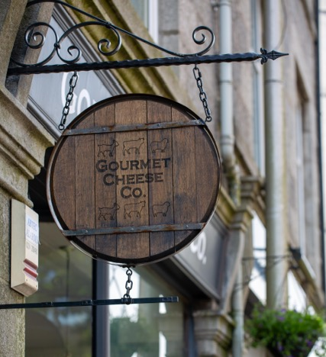
Gourmet Cheese Co.
201 Rosemount Place, Aberdeen, AB25 2XP TEL.01224 566530
Christmas Pre-orders

Date of Collection: |  | Customer Name & Contact Number:
Item: (Please see website for full range of stock including cheese, biscuits, oatcakes, crackers, chocolates, coffee etc. ) | Approx. Weight/ Quantity | Cheese Hampers:  These are pre-set and cannot be amended.  £25 Hamper _x_________  £45 Hamper _x_________  £60 Hamper _x_________  Bespoke Hamper _________  (Please state amount (£) in which you would like us to spend on your hamper)  ***If you do not know approx. weights, please state a maximum amount that you would like to spend.
Maximum Spending amount:

Please note: That the last day for collection is December 24th. For Deliveries, please contact the store directly.

